**Business Premise Photo**

|  |  |
| --- | --- |
| **Business Address:** | No.86, Street 214 corner of Street 111, Sangkat Boeung Prolit, Khan7 Makara, Phnom Penh Capital |
|  |  |

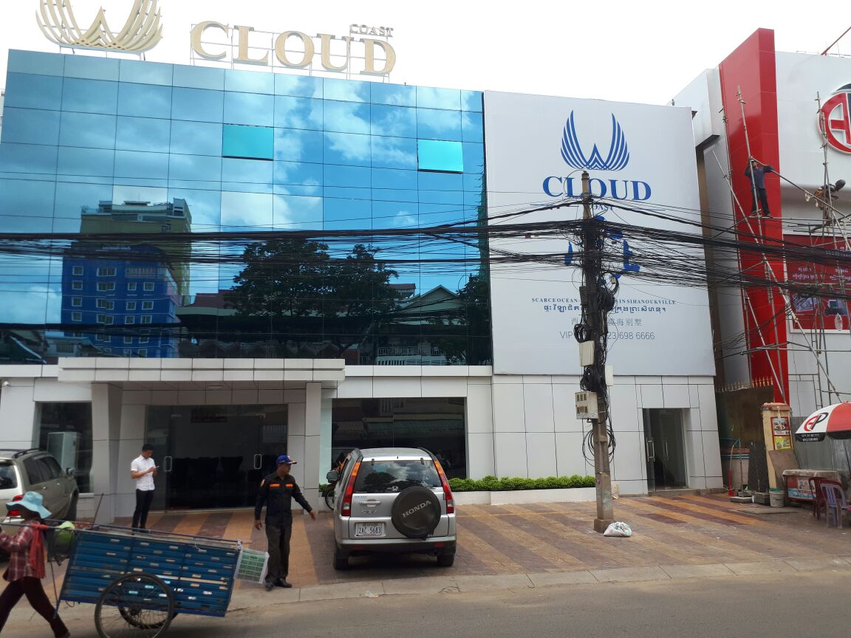

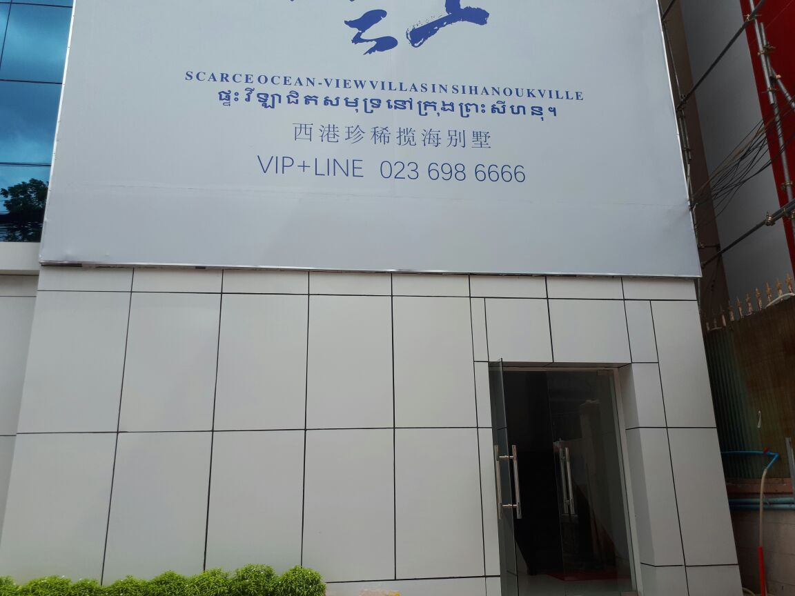

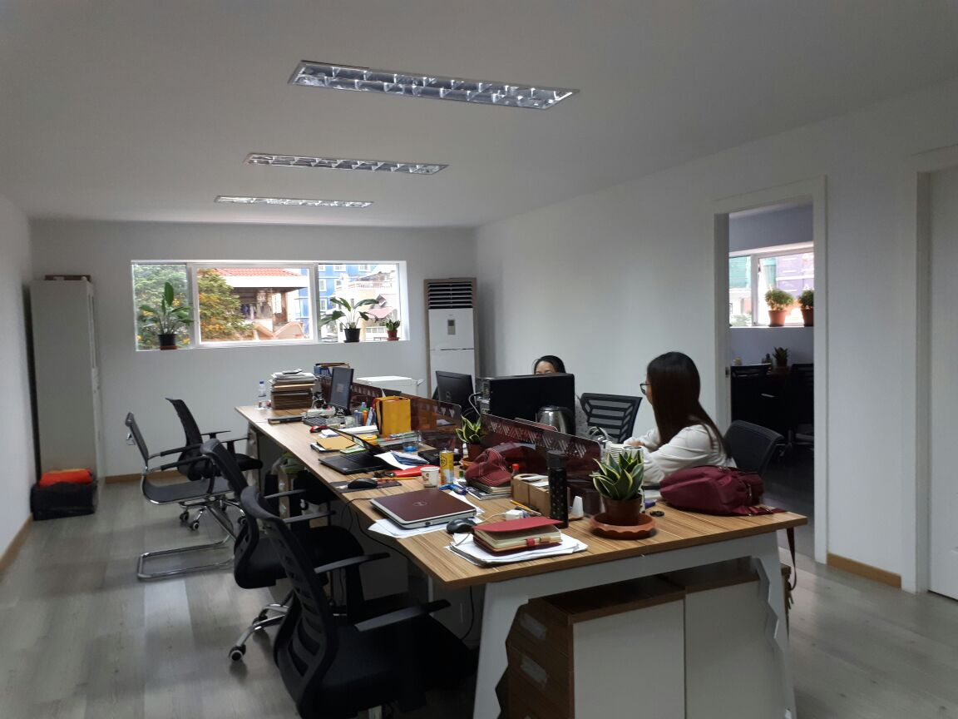



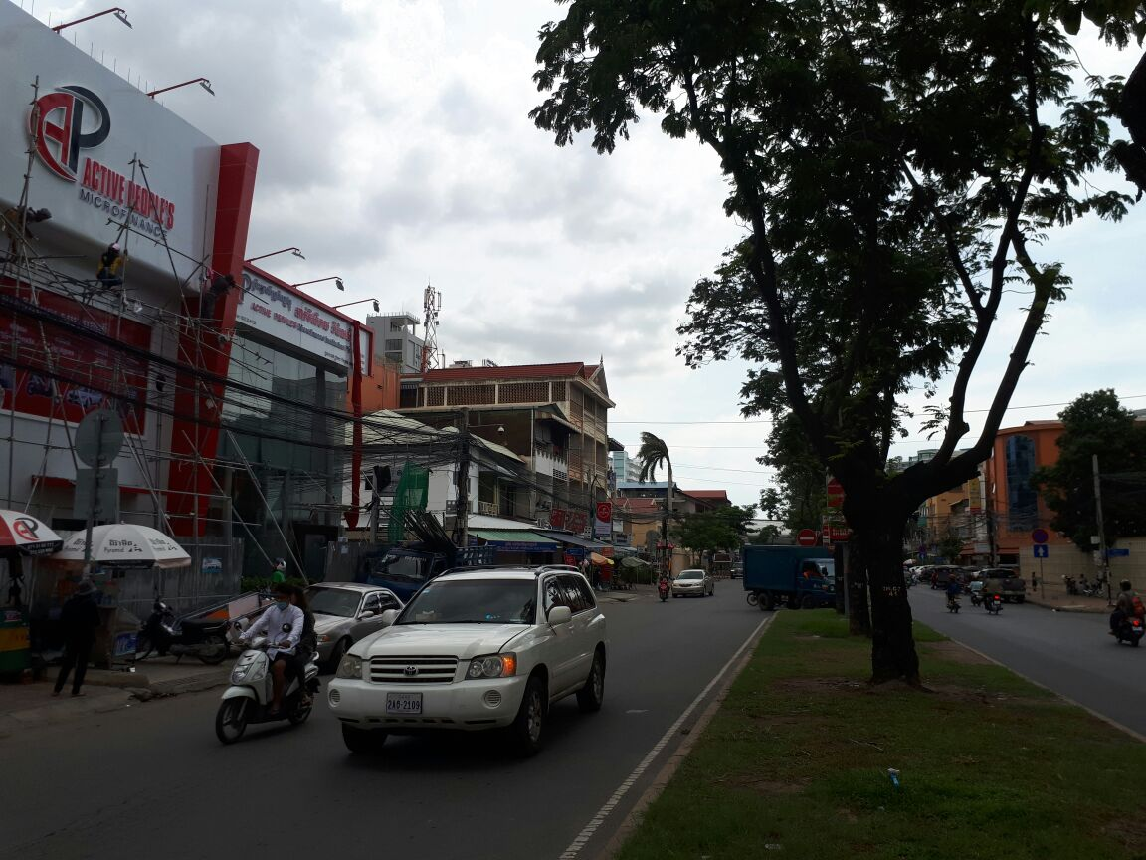

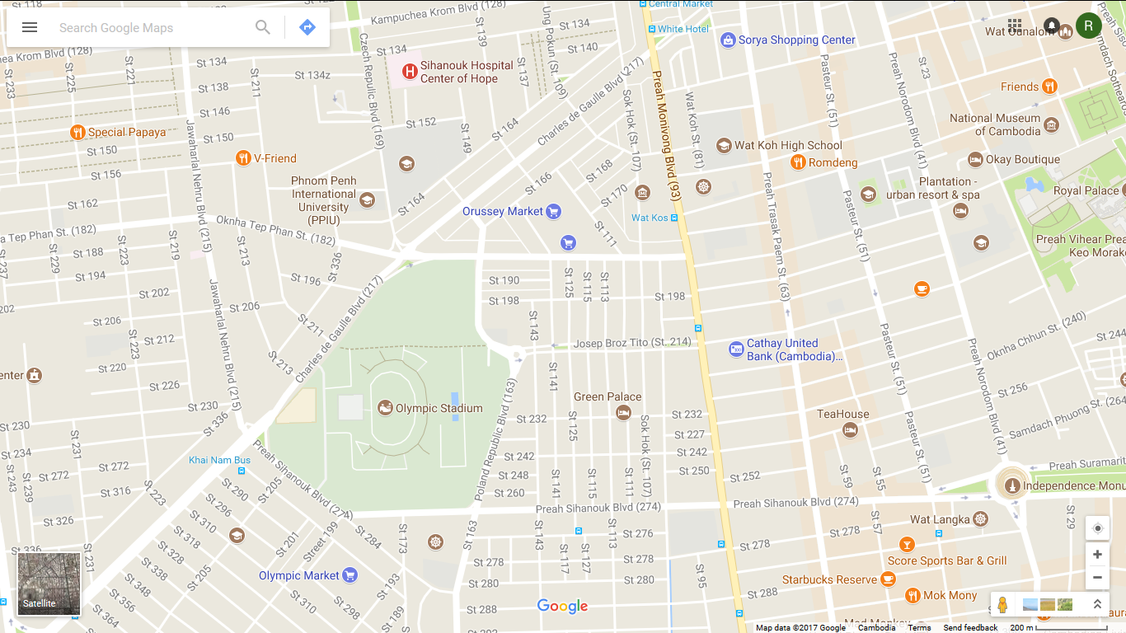

Business Location